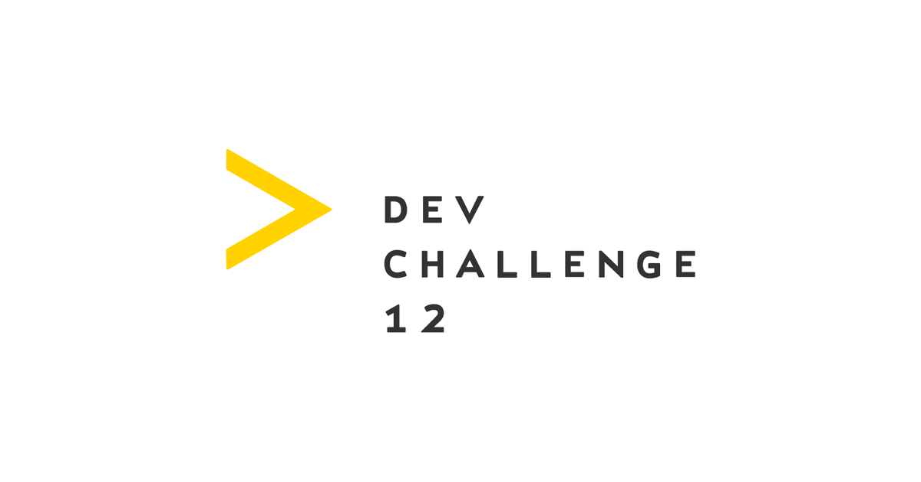

|  |  |  |  |
| --- | --- | --- | --- |
| ID | Author | Version | Date |
| TP_1 | DevChallenge-QA | 1.0 | Jun 2, 2018 |

**OpenWeatherMap – Test Plan**

**Update history:**

|  |  |  |  |
| --- | --- | --- | --- |
| Date | Author | Version | Description |
| Jun 2, 2018 | DevChallenge-QA | 1.0 | Initial draft |

**References:**

|  |  |  |  |
| --- | --- | --- | --- |
| Document | Author | Version | Description |
| Checklist.xlst | DevChallenge-QA | 1.0 | List of tests |
| Test Report.docx | DevChallenge-QA | 1.0 | Summary of test activities |
| Bug Report.docx | DevChallenge-QA | 1.0 | List of found defect |
| Weather API | Openweathermap.org | - | <https://openweathermap.org/api> |

# 1. Introduction

1.1. Application Description

**OpenWeatherMap** is an online service that provides weather data, including current weather data, forecasts, and historical data to the developers of web services and mobile applications. For data sources, it utilizes meteorological broadcast services, raw data from airport weather stations, raw data from radar stations, and raw data from other official weather stations.

1.2. Purpose

This document defines a test plan to test implementations of the OpenWeatherMap Application Programming Interface (API) - <https://openweathermap.org/api>. It establishes a common understanding of the testing activities, identifies the items being tested, the overall approach of the testing activities, detailed testing tasks, defines the testing environment and describes the testing tools required for API testing.

# 2. Test Items

Test items covered in this document are OpenWeatherMap API services: <https://openweathermap.org/api>.

2.1. Features to be tested

|  |  |
| --- | --- |
| Feature | Reference |
| Current weather data | <https://openweathermap.org/current> |
| 5 day / 3 hour forecast | <https://openweathermap.org/forecast5> |
| Weather map layers | <https://openweathermap.org/api/weathermaps> |
| UV Index | <https://openweathermap.org/api/uvi> |
| Weather stations | <https://openweathermap.org/stations> |
| Weather alerts | <https://openweathermap.org/triggers> |
| Air pollution | <https://openweathermap.org/api/pollution/co> |

2.2. Features NOT to be tested

The following items cannot be tested due to lack of the precondition data, which is required for test execution:

|  |  |
| --- | --- |
| Feature | Reason |
| 16 day / daily forecast | Requires at least Starter subscription |
| Historical data | Requires at least Starter subscription |
| History Bulk | Requires at least Starter subscription |
| Bulk downloading | Requires at least Professional subscription |

# 3. Approach

3.1. Test Process Overview

Testing will be performed by dedicated QA Engineer according to defined test plan. The testing phase will involve only Integration level. Tests will be run automatically using defined testing tools.

The philosophy of the testing is risk­based testing, i.e. each item in checklist will be

prioritized as, High, Medium, or Low priority and then scheduled accordingly (Highest first).

QA process will consist of the following activities:

* functional requirements analysis;
* test planning;
* test design;
* test execution;
* test automation;
* defect tracking;
* test closing activities;
* creating and updating testing artifacts.

3.2. Testing methods

* manual testing;
* automation test using defined test tools.

3.3. Test documentation

* Overall testing process, tools and approach is described in **Test Plan** document.
* **Checklist** document will be used for test design and test execution. Each item in checklist mush have ID in order to track tested items/automated tests.
* **Bug Report** will be used to provide information about found defects.
* **Test Report** will be used to list overall information of test results.

# 4. Test Item Pass/Fail Criteria

The test features will be tested according to the product OpenWeatherMap API requirements which are mentioned in Section 3.

If more than 85% of the tests for feature fail, the test feature is considered to have failed. If more than 85% of tests for feature pass, the test feature is considered to have passed.

All tests with High priority must pass.

Test Coverage must be at least 85%. Automation coverage must be at least 80%.

# 5. Test Deliverables

The list bellow describes test deliverables that will be used on the project:

|  |  |  |
| --- | --- | --- |
| **ID** | **Name** | **Description** |
| TP_1 | Test Plan | Describes overall test process, approach, tools. |
| CL_1 | Checklist | Include lists for tests, pass/fail results, automation coverage |
| TR_1 | Test Report | Describes summary of test activities |
| BR_1 | Bug Report | Information about defects |

# 6. Tools

|  |  |  |
| --- | --- | --- |
| **Tool** | **Purpose** | **Description** |
| Microsoft Office | Writing test documentation (test plan, test report) | Application for text document creation |
| Microsoft Excel | Creating and maintaining Checklist | Application for spreadsheet creation. |
| Postman | API testing and automation | HTTP client for testing web services |
| Newman | Running API test in console | Command-line collection runner for Postman |
| Google Chrome | Exploratory testing | Browser by Google |

# 7. Test Schedule

**Start Date:** 25.05.2018

**End Date:** 03.06.2018

# 8. Risks

* lack of availability of required environment ;
* environment limitations;
* uncompleted requirements and lack of details;
* no users defined acceptance criteria exists for performance testing.

# 9. Approvals

|  |  |  |  |
| --- | --- | --- | --- |
| **Position/Title** | **Name** | **Signature** | **Date** |
| QA Lead | DevChallenge Judge | - | - |